# Project Part 1: Creating a Business Program in C++

## Business Program Requirements Project:

In Project Part 1, you will create a program for a type of small businesses. The program should incorporate all required elements as listed and described in Chapters 1 – 7. The program **cannot** address employee hours, salary, wages. This program is intended to improve business process and operation flow.

#### Business Types:

Select from 1 of the following types of small businesses.

1. Restaurant (program for customers, server, chefs, staff operation).
2. Beauty salon/spa (program for customers or staff operation).
3. Coffee shop (program for customers, baristas, or staff operation).
4. Clothing retailer (program for customers, clerks, or staff operation).
5. Health food retailer (program for customers, clerks, or staff operation).
6. Gym with training programs (program for members, trainers or staff operation).
7. Office supply retailer (program for customers, clerks, or staff operation).
8. Furniture retailer (program for customers, clerks, or staff operation).
9. Shoes retailer (program for customers, clerks, or staff operation).
10. Mailing and shipping center (program for customers, clerks or staff operation).
11. Pet grooming service provider (program for clients, groomers or staff operation).
12. Pet supply retailer (program for customers, clerks or staff operation).
13. Smartphone prepaid retailer (program for customers, clerks or staff operation).
14. Urgent care provider (program for patients, doctors, nurses or staff operation).
15. Pharmacy (program for patients, pharmacists, clerks or staff operation).
16. Home repair/construction provider (program for clients, worker, or staff operation).
17. Medical marijuana dispensary (program for patients, clerks, or staff operation).
18. Business and resident cleaning service provider (program for clients or staff).
19. Car wash (program for customers or staff).
20. Gas station (program for customer, clerks, or staff operation).
21. Nursery (program for customer, clerks or staff operation).
22. Hardware store (program for customer, clerks or staff operation).
23. Bakery (program for customer, bakers or staff operation).
24. Ice-cream parlor (program for customer, clerks or staff operation).
25. Nutrition center (program for customer, clerks or staff operation).
26. Sporting goods retailer (program for customer, clerks or staff operation).

## Part 1A: Program Flowchart, Pseudocode and Documentation:

1. In small group (2-3 students), select the business type.

The Business Type that we have chosen is S. Car wash (program for customers or staff).

1. Provide team name (your software company name), team members and roles.

Our Team Name is J.M.F. corporation. The name of the carwash is called Mr. Quick’s Clean Car Wash. The team members are Francisco Benitez, Joshua Buckles, and Mitchell Houser. Our roles are Francisco Benitez: Documentation. Joshua Buckles: pseudo-code. Mitchell Houser: flowchart.

1. Create a flowchart of the program based on business and technical objectives.

Flowchart by Mitchell Houser

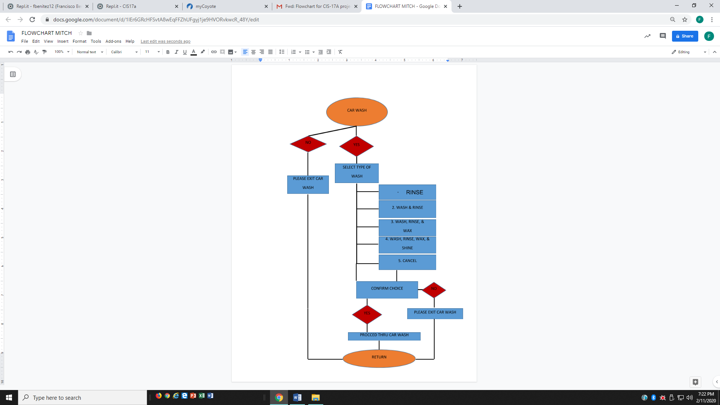

1. Use the standard flowchart shapes as explained in Unit 1 of the course.

The flow chart by Mitchell Houser does indeed use the proper flowchart shapes to show how the program is lay out and how it will run.

1. Create a pseudo-code for the program.

Pseudo-code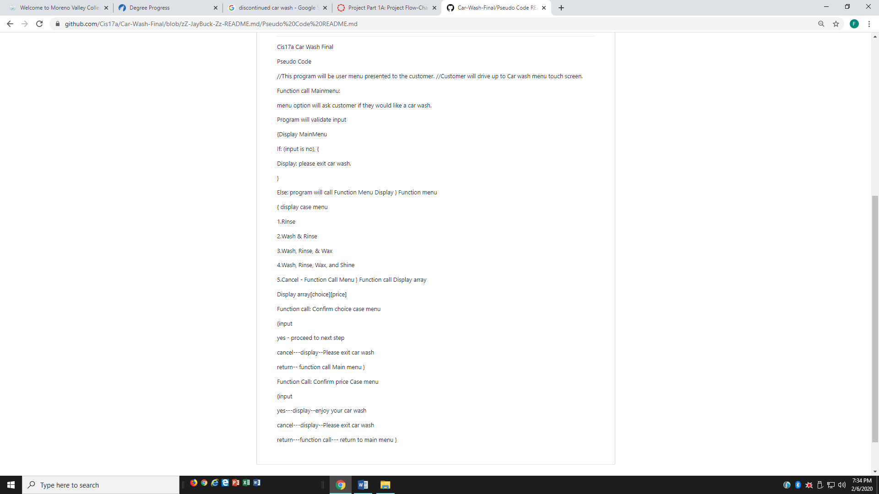: By Joshua Buckles

1. Create a short documentation describing the program purpose, function, and objectives.
   * Minimum a page is required.
   * This document should explain the purpose of your program, targeted audience/type of users, and business functions.
     + Who is it for?
     + What is its purpose?
     + What is its business function?
     + What is its technical function?

Submission: Document contains flowchart, pseudocode, and program documentation.

This program is for people who do not want cheap gas station car washes or annoying 5$ “donation” dollar high school run washes. J.M.F. corporation have created a program that will allow customers to interact with a state-of-the-art touch screen menu that will make choosing a carwash package fast and simple.

The purpose of this program is for customers who need their car washed efficiently and fast at a great price. The customer will drive up to Car wash (Mr. Quick’s Clean Car Wash) and will interact with touch screen menu program before going into the car wash. There the customer will have a variety of carwash package options to select from. From a basic water rinse to wax and shine, the customer will be in control in what type of wash they want on their car.

The business function of this program is to compete against local carwashes in town like a gas station owned car wash or high school football, cheer teams, or marching band car washes or big chained car wash companies like Quick Quack Car Wash. This program will allow customers to easily select their choice of wash quickly and as simple as possible at a great price.

The technical function of this program is that the car wash program will make deciding a package of carwash and confirming it smooth and trouble-free. It will also be straightforward if the selection of the wash is not what the customer wants. In addition to this, the carwash program created by J.M.F is efficient, uncomplicated, and user-friendly as to those programs that are complicated, timewasting and ineffective. This is what Mr. Quick’s Clean Car Wash program offers to its customers.